Consequences of rapid urbanisation   
– Teachers’ notes

Why do slums develop? Who lives there? And are they places of hope or places of despair? Use these materials about Mukuru – a slum in Nairobi in Kenya – to construct an enquiry around the development of urban slums.

These teacher notes and accompanying film, presentation, photo pack and pupil sheets, are designed to support a KS3 unit of work. The full collection can be downloaded at [*www.tes.co.uk/rednoseday*](http://www.tes.co.uk/rednoseday)

Objectives

* Developing geographical skills such as map work, photo and data interpretation and analysis, and GIS skills
* Adding to geographical vocabulary
* Improving knowledge of African geography, migration and urbanisation processes and consequences
* Developing enquiry skills

Curriculum links

2.1f Plan geographical enquiries, suggesting appropriate sequences of investigation

2.2a Select and use fieldwork tools and techniques appropriately, safely and efficiently

2.4a Use geographical vocabulary and conventions in both speech and writing

3b Include a range of investigations, focusing on places, themes or issues

3g The study of human geography, built and managed environments and human processes

Resources

* Film: ‘Welcome to my world’ (Dennis’s story)
* Presentation: ‘Consequences of rapid urbanisation’ (with notes for teacher reference)
* Photo pack: Dennis
* Pupil sheets:
  + Exploring Nairobi using Google Earth
  + Outline maps: 1. Kenya; 2. Africa
  + Line drawings to annotate: 1. House; 2. Street
  + Map of Wajir and Nairobi
  + Comparative data for the counties of Wajir and Nairobi
  + Population data for constructing population pyramids (with graph paper)
  + Worksheet: ‘Characteristics of urban slums’
  + Worksheet: ‘Jua Kali’
  + Key terms definition cards

Constructing an enquiry

Step 1

The class need to start by generating questions. To stimulate questions you could use clips from ‘Welcome to my world’, the Comic Relief video about life in Mukuru for a young boy called Dennis, or the photo pack, or the first couple of slides in the presentation. If your pupils have not worked through an enquiry-based piece of learning before then spend time developing their understanding of good questions and the importance of using Who, What, Where, When, Why, How. At this stage pupils should work independently, writing down on sticky notes all the questions that come to them as they view the stimulus material.

Step 2

Working in small groups pupils compare and collate their questions. They could stick their questions on a large piece of paper, grouping similar questions together.

Step 3

Still in their small groups, they discuss their reactions to the film and the photographs and   
come up with more questions. They will need prompting to ensure their questions are the best ones possible. You could use the checklist below. Each group should aim for at least 12, but no more than 25, questions. You could either guide the class to come up with their list of questions or get them to refer to a similar list on the wall.

Step 4

Use the matrix below to scaffold the enquiry, starting with the most significant question at the top.

Step 5

Next choose a range of secondaryor sub-questions (3 to 6), which will structure the enquiry.

Step 6

Finally, break down the secondary questions into lists of ‘what we need to know’ – these are called the ‘grab and go’ questions. They are generally facts that are relatively easy to find out, but they need the structure of the secondary question to add purpose to the learning.

Checklist for enquiry

* Are my questions geographical?
* Do my questions use geographical words (vocabulary)?
* Do my questions cover Who? What? Where? When? Why? How?
* Do any of my questions require me to think about different opinions or sides of an argument?
* Can some of my questions be answered with only facts?
* Will some of the questions need me to use skills such as using maps or photographs?
* Have I thought of one big important question, which I am trying to research and answer?

Examples of enquiry questions

* How would you make life in Nairobi’s slums better for the people who live there?
* How does life for the poorest in Nairobi compare with life for the poorest in my nearest city?
* Why are there slums in Nairobi and why do people live in the Mukuru slum settlement?
* Are slums places of hope or despair?

**Are slums places of hope or places of despair?**

Suggestions for KS3 unit of work

**Where are the slums?**

**A**

**What are slums?**

**C**

**Why do slums develop?**

**B**

**Who lives in the slums?**

**D**

**How and when will life improve in the slums?**

**E**

**A**

Are there slums in every country? Where are the biggest slum areas?

How do slums in different parts of the world compare?

How could I use Google Earth to find and compare slums in different parts of the world?

Where in the city do you find slums?

How do economic, demographic and social characteristics of a slum compare with other parts of its host city?

Are slums purely an urban phenomenon?

**B**

Where do all the people in the slums come from?

What is rural to urban migration?

What can I find out about one part of Kenya that people have migrated from?

What are the positive things about cities?

What is an informal, unplanned settlement?

Why do people live in the slums?

Are people in slums squatting?

Where can I find out more about the history of one slum area?

**C**

What materials are used to construct slum housing?

Do children in slums go to school?

What health problems are found in slums?

How many people per toilet?

What would my life be like if I lived in a slum?

What are the problems with water, sanitation and transport in the slums?

What are the environmental characteristics of slums?

What are the economic characteristics of slums?

What are the political characteristics of slums?

How do we define slum conditions?

**D**

Do people live in slums as a temporary solution?

In what ways are slums risky places lived in by risk takers?

What is life like for children in the slums?

What are the social and demographic characteristics of slums?

**E**

Will there be more or fewer slums by 2050?

What was the site and services scheme?

Are slums inevitable consequences of development and rapid urbanisation?

How can mobile phones help people improve their lives in the slums?

What are the barriers to improving the slums?

What are community-rebuilding schemes and how are they financed?

Suggested themes and resources

*Your enquiry will be driven by the core questions generated by you and your pupils. Below gives a suggestion of how the resources in this pack could be used to support your enquiry.*

**Where** are the slums?

* Film: ‘Welcome to my world’ (Dennis’s story)
* Presentation: ‘Consequences of rapid urbanisation’, slides 2–10
* Pupil sheets:
  + Exploring Nairobi using Google Earth
  + Outline maps: 1. Kenya; 2. Africa

**Why** do slums develop?

* Presentation: ‘Consequences of rapid urbanisation’, slides 11–18
* Pupil sheets:
  + Map of Wajir and Nairobi
  + Comparative data on Wajir and Nairobi
  + Population data for constructing population pyramid (with graph paper)
  + Key terms definition cards

**What** are slums?

* Film: ‘Welcome to my world’ (Dennis’s story)
* Presentation: ‘Consequences of rapid urbanisation’, slides 20–26
* Photo pack: Dennis
* Pupil sheets:
  + Worksheet: ‘Characteristics of urban slums’
  + Line drawings to annotate: 1. House; 2. Street
  + Worksheet: ‘Jua Kali’

**Who** lives in the slums?

* Film: ‘Welcome to my world’ (Dennis’s story)
* Presentation: ‘Consequences of rapid urbanisation’, slide 18-19
* Photo pack: Dennis
* Pupil sheets:
  + Population data for constructing population pyramid (with graph paper)

**How** and when will life improve in the slums?

* Presentation: ‘Consequences of rapid urbanisation’, slides 27–33

**When** is Red Nose Day 2013 and what can we do?

* Presentation: ‘Consequences of rapid urbanisation’, slides 32–33

Background information for teachers

*The background information on the following pages is provided to give context to your unit of work and to help you plan how you will guide your pupils through an enquiry on slum settlements. The notes are divided into clear sections, which can be used as required.*

History of Nairobi as an urban area

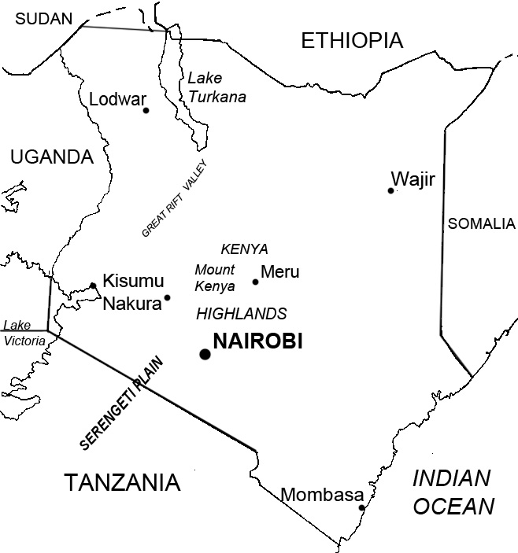

Situation

The western part of the city is the highest and has the **Ngong Hills.** The eastern side is lower and flat. There are three rivers running through Nairobi – **the river Ngong**, **river Nairobi** and **river Mathare.** They can be seen in many of the slum districts. There are forests in Northern Nairobi and a **national park nature reserve** in the south west. **Mount Kenya** rises further away in the north and **Mount Kilimanjaro** is across the border with Tanzania to the south east. Minor earthquakes and tremors occasionally shake the city, as Nairobi sits next to the **Rift Valley**, which is still being created as tectonic plates move apart.

History

Nairobi originated as the headquarters of the Kenya Uganda Railway, which was established when the railhead reached Nairobi in June 1899. The city grew into British East Africa’s commercial and business hub and by 1907 became the capital of Kenya. Population: 1948 = 120,000, 1999 = 3 million, 2010 = 3.2 million

Economic growth

Nairobi has a large manufacturing sector, including metals, electricals, packaging, plastics, chemicals, timber products, pharmaceuticals, clothing and shoes, and food processing. It also has a growing financial sector and technology, phone and computer technology sector. It is geographically well positioned to link African business to the rest of the world. This is helped by frequent airline connections and investment in fibre optic cables that give good network facilities. There are also high-profile organisations that have headquarters or regional offices there, e.g. IMF, World Bank and United Nations (UNEP programme). Nairobi is African or East African headquarters for the following companies IBM, Coca Cola, Google, Cisco Systems, Citibank, and Price Waterhouse Coopers.

Land use in the city

Land prices in the Central Business District (CBD) are high, so some businesses have moved to new business parks in Upper Hill (SW) and Westlands (W) where there is more space. Modern shopping complexes have been built to the west and north among the high-end housing with its gated communities.

Nairobi is made up of eight divisions or administrative areas. There are informal settlements in all eight divisions. For an excellent map of Nairobi showing divisions and their informal settlements see figure 4 on page 152 of [www.unep.org/dewa/africa/kenyaatlas/PDF/KenyaAtlas_Chapter5.pdf](http://www.unep.org/dewa/africa/kenyaatlas/PDF/KenyaAtlas_Chapter5.pdf)

|  |  |  |  |  |  |
| --- | --- | --- | --- | --- | --- |
| **Division** | **Pop in 000s** | **Pop density Per km2** | **Slum settlements referred to  in the resources** | **Where is it?**  **What are the features of the area?** | **On Google maps or Open Street Map search for:** |
| Langata – Kibera | 287 | 1284 | Kibera | S of city. Largest of Nairobi slums settlements. River Ngong runs through. Airport nearby. Featured in Comic Relief’s 2011 documentary *Famous, rich and in the slums* | ‘Kibera Drive’ or  ‘Kambi Muru Mosque’ |
| Embakasi | 435 | 2088 | Muruku – includes several settlements including  Mukuru kwa njenga  Mukuru kwa Reuben  Kyang’Ombe  Sisal  (Mukuru also falls in Makadara division) | SE of city. River Ngong is northern border. Outer edge of division goes to 20km+ from city centre. Most of working population employed as casual labour or small-scale industries known as Jua Kali sector | ‘Diamond Village, Mukuru’ |
| Westlands | 208 | 2127 | Suswa village | NW of city .Majority residents working as domestic workers in Parklands and Westlands suburbs | ‘Suswa Road, Parklands’ |
| Kasarani | 339 | 3955 | Mathare | North (outer) – extends to 20km+ from city centre. Most residents employed or self-employed  in the Jua Kali sector as casual and semi-skilled labourers | ‘Mathare’ |
| Dagoretti | 241 | 6215 | Pipeline village | West (outer) edge extends to 20km+ from centre. Established in 1979 by residents evicted from their previous residences during the Nairobi City Council slum clean-up campaign of 1971-78 | ‘Kawangware’ |
| Makadara | 197 | 9823 | Mariguini  Mukuru Nyayo  Kisii | SE (inner) - edge extends to 5km from city centre. 50% working pop employed in Nairobi industrial area which is easy to get to from here | ‘Kisii village’ |
| Pumwani | 202 | 17283 | Buru Buru or Carton village | E and NE – a narrow belt extending from centre out to far edge of city based on the industrial area. Most of working population employed as casual labour or small-scale industries known as Jua Kali sector | ‘Buru Buru’ |
| Central – Starehe | 235 | 22164 | Huruma  Corner Mbaya  Kambi Moto | Centre. CBD / business functions/ modern multi storey buildings. Nairobi River runs through it | ‘Huruma’ or ‘Kamunde Road’ |

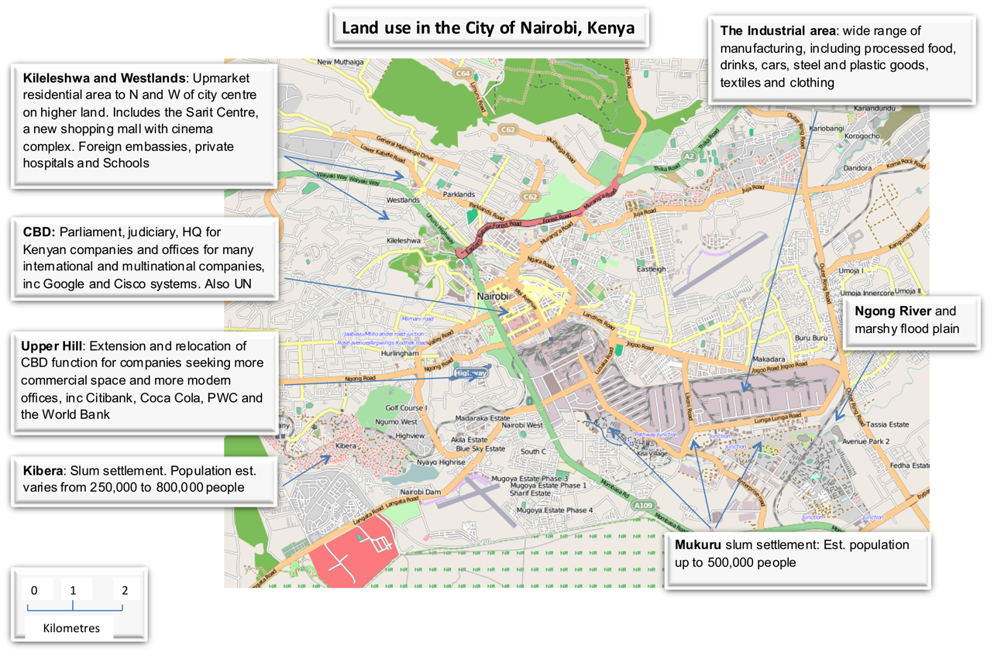

Background to slum development



1900 to 1963 – colonial era

Segregated residential layout with strictly policed entry to each area requiring passes. White areas to west on higher land with housing for native Africans squashed between the CBD and the industrial area. Laws restricting native travel controlled the expansion of their housing area. The legacy of this time is a biased distribution of land skewed against the black native population. 50% of Nairobi’s population inhabit just 5% of the residential area or 1% of total city land.

1960s & 70s – post-colonial era

Kenya was granted independence in 1963. With independence came the lifting of restrictions on entry and travel to any part of the country. Nairobi began to grow rapidly as the city was perceived to offer employment opportunities. The population in 1948 was 120,000. By 1999 it was estimated at 3 million.

Inadequate planning led to expansion of the slums and new slums developing. The slums developed on poor-quality land such as Riparian reserves, swamps, steep slopes, refilled quarries, garbage dumps, railway safety zones, land beneath high voltage power lines and road reserves. Slums were areas of high population density and this was a factor in leading to a rise in political activism at the end of the 70s and early 80s. Officially slums were not recognised and were shown as ‘unoccupied’ on maps.

1980s & early 90s – the Moi era

It was common for land to be used as a bribe, reward or to purchase political favours. Land given away in this way included public land and government land already occupied by informal settlements. The new ‘owner’ would generally want to evict the informal settlers.

The site and services schemes of the 70s and 80s, for example in a suburb of Nairobi called Dandora, were early slum upgrading projects sponsored by USAID and World Bank. Though hailed as a success at the time, it is now clear that these projects did not meet cost-recovery standards and left a legacy of debt to national governments. The schemes were discredited when people sold on property for large profits without provision for affordable maintenance of sewerage and water systems. Studies started to reveal that sites and services schemes were not reaching the target populations and that many housing units meant for low-income beneficiaries were being bought out by individuals with higher incomes.

1990s to present

International agencies, spearheaded by the World Bank, encouraged an ‘enabling’ approach for housing delivery. Rather than assuming the role of the primary provider of housing, governments were encouraged to create incentives that fostered improvements in housing through the private and NGO sectors.

The **Mathare 4A Development** in Nairobi was one such project in Nairobi. Though successful in upgrading living conditions, improving infrastructure and providing new facilities for 22,000 people – all without displacing any tenants – there were many problems and violent protests because the owners of the structures were not allowed a say, so they took the Nairobi City Council to court and delayed construction.

Communities realised they needed to participate in the planning stages of a new development to ensure that it would benefit them. In 1996 civil society organisations came together as a lobby group called **Muungano Wa Wanavijiji**. Their aim was to unify the voice of the urban poor. The new organisation was very successful in stopping new private landlords taking over the land for development. There were far fewer evictions and Nairobi City Council recognised the need to address the slum issue because:

* The electorate were demanding more accountability from Government.
* High profile campaigns of civil society and communities were making it difficult to continue to ignore the slum issue.
* International pressure was mounting for Government to adopt pro-poor policies.
* There were persuasive and strong individuals within Nairobi City Council, who were increasingly effective and helped collaboration through the Nairobi Informal Settlements Coordination Committee.

In 2008, the Government of Kenya produced the **Nairobi Metropolitan Development Plan**, committing to:

* Developing integrated road, bus and rail infrastructure for the Metropolitan Area to provide an efficient mass transport system
* Replacing informal settlements with affordable, low-cost housing
* Developing and enforcing planning and zoning regulations and preparing a spatial plan for the Metropolitan Area
* Developing efficient water supply, waste management infrastructure and investing in public services
* Promoting, developing, and investing in sufficient public utilities, public services, and world-class infrastructure
* Developing a sustainable funding framework for this work

Comic Relief – People Living in Urban Slums Programme

Comic Relief is a UK-based charity which strives to create a just world free from poverty.

Comic Relief uses money raised through its two fundraising campaigns, Red Nose Day and Sport Relief, to award grants to on-the-ground projects that support some of the poorest and most disadvantaged people in the UK and around the world.

Grants are awarded through Comic Relief’s [UK Grant Making](http://www.comicrelief.com/sites/comicrelief.com/assets/documents/resources/UK-full-Grants-Strategy.pdf) and [International Grant Making](http://www.comicrelief.com/sites/comicrelief.com/assets/documents/resources/International-Grants-Strategy.pdf) strategies. The People Living in Urban Slums programme is one of six programmes which make up the International Grant Making Strategy. The goal of the programme is to empower slum dwellers to drive improvements in their own communities. The programme currently has approximately 30 live grants, worth a total of £18 million, across 14 African countries.

Projects supported through the programme include, schemes dedicated to improving the living environment of slum dwellers (by providing access to water, sanitation and waste removal); projects that help individuals to improve their economic prospects (through training and small business development); and projects that promote security of tenure by helping slum dwellers to identify and represent their needs and rights to governments, local authorities, landlords and others in power.

The programme also supports a number of affiliates of Homeless International (like Pamoja Trust and its partners – see below) which help slum dwellers to pool their resources and improve their housing by setting up savings clubs and contributing communally to house-building schemes.

For further information about Comic Relief’s grant-making programmes visit [www.comicrelief.com/how-we-help](http://www.comicrelief.com/how-we-help)

|  |  |  |
| --- | --- | --- |
| Case Study – The Pamoja Trust  The Pamoja Trust is a partner organisation to Muungano wa Wanavijiji, founded in 2000. The focus of the trust is to provide a voice for slum dwellers and help with negotiations between landlords, city councils, developers, etc. in order to improve conditions in the slums and reduce evictions.  The focus of Pamoja’s work is community-led upgrading of informal settlements. It generates social capital through community empowerment, mobilising communities, creating change and collective action. Pamoja emphasise that the two tools to make change happen are the setting up of savings schemes and the process of enumeration.  The Pamoja Trust has been part-funded through Comic Relief’s People Living in Urban Slums programme since 2000. For more information about Comic Relief and their grant-making strategies visit [www.comicrelief.com/how-we-help](http://www.comicrelief.com/how-we-help). | | |
| Savings schemes  A main focus of the group was organising savings groups. Daily savings are a mechanism or simple system for mobilizing and organising communities to save capital towards investment in projects such as housing schemes. 10,000 people in Kenya are currently paying into schemes like this. Specific people are appointed to collect small amounts of money door-to-door. | | Enumeration  Enumeration is the process of taking a census of an area to determine who lives there and gather information about their age, gender, origin, employment, the condition of their home and level of wealth. Before 2000, large areas of the Nairobi slums were unmapped and there was no census data.  The enumeration of the settlements in Nairobi is a process that takes about 10 days and is undertaken by the residents themselves. Data is collected, accurate mapping takes place and the residents meet to discuss their main priorities for their neighbourhood. The enumeration found that after rent the main items of expenditure for households in Mukuru were food, water and toilet facilities and the thing most people wanted was security of tenure. |
| Case study of successful intervention by Pamoja Trust – Kambi Moto  **1970s to 1990s** there were problems with severe overcrowding, inadequate housing construction and fires.  In **2000** A Muungano savings scheme was formed.  In **2001** an enumeration of all residents was carried out.  In **2002** the Pamoja Trust helped residents negotiate with the city council to gain control of occupied land, create a special planning area and agree innovative construction styles and methods that would not meet their usual planning regulations but were affordable and appropriate and represented a huge improvement in the quality of living conditions for the residents.  In **2003** construction of housing began. The council partnered in the project.  In **2012** construction of additional units and upgrading continues. There is strong community involvement and empowerment. The Kambi Moto settlement is not only residential; there is also a lot of economic activity in the area largely targeted at the needs of the residents themselves including shops, eateries and services. The settlements also have village kindergartens, early primary schools, and places of worship. | | |
| Problem | Solution | |
| Lack of capital | Consolidate funds into savings scheme and putting this towards savings and loan repayments. Savings funds used as deposit (20%) to borrow housing loan funds (80%) from an urban-poor fund called Akiba Mashinani Trust (AMT). Individuals then pay back these loans like a mortgage | |
| Lack of know-how | Pamoja help coordinate the project manager and architect.  [www.worldhabitatawards.org/winners-and-finalists/project-details.cfm?lang=00&theProjectID=18A60F52-15C5-F4C0-99C4EF674461D6A1](http://www.worldhabitatawards.org/winners-and-finalists/project-details.cfm?lang=00&theProjectID=18A60F52-15C5-F4C0-99C4EF674461D6A1) | |
| Lack of income/cash flow | Construction is carried out by the residents themselves.  Most people can only afford a ground-floor unit to start with but can add additional floors later. The roof slab is used as a roof terrace until residents can build an extra storey. | |
| Land ownership and planning regulations issues | Pamoja helps residents negotiate with city council to gain control of land. | |
| Bureaucracy | Council made special planning zone agreement to allow innovative and appropriate construction. | |
| High population density | Innovative building design allows dense habitation. Volume of people involved used to advantage as labour, and for giving access to network of know-how etc. for building project. | |
| Very little land available | House footprint could not exceed 4.5 x 4.5m. Narrow streets and paths. | |
| For photos of Kambi Moto settlement see  [www.homeless-international.org/our_projects_1.aspx?id=0:59592&id=0:59188&id=0:59163&id=0:59153](http://www.homeless-international.org/our_projects_1.aspx?id=0:59592&id=0:59188&id=0:59163&id=0:59153)  and  [www.design.upenn.edu/new/cplan/minisite/casestudies/hurumacase.pdf](http://www.design.upenn.edu/new/cplan/minisite/casestudies/hurumacase.pdf) | | |

Characteristics of slum settlements

Definition

UN-HABITAT has developed a household-level definition of a slum household in order to be able to use existing household-level surveys and censuses to identify slum dwellers among the urban population. A slum household is a household that lacks any one of the following five elements:

a. **Access to improved water** (access to sufficient amount of water for family use, at an affordable price, available to household members without being subject to extreme effort)

b**. Access to improved sanitation** (access to an excreta disposal system, either in the form of a private toilet or a public toilet shared with a reasonable number of people)

c. **Security of tenure** (evidence of documentation to prove secure tenure status or de facto or perceived protection from evictions)

d. **Durability of housing** (permanent and adequate structure in non-hazardous location)

e. **Sufficient living area** (not more than two people sharing the same room)

Living conditions

**Housing:** Less than 20% of houses in most Nairobi slum settlements are owner occupied (comparatively 50% in London and 67% in UK). It is estimated that it would take 34 years for an average poor household in Nairobi to save enough to buy a simple house costing $4000. You need an earned income of $70 per month to be able to rent a house, so, as most slum dwellers have income of just $40 month, they have to share a room.

A wooden frame with corrugated iron sheets (mabati) on the outside and a lining of cardboard is the most common building construction. Buildings are generally 10ft x 12ft single-storey shacks. Less than 20% of them have a concrete slab floor. As drainage of the site is generally poor, and many slums are built on riparian reserves (river banks), flooding is common. Use of oil lamps in places where there is no electricity creates a noxious fume hazard and increases the risk of fire, which spreads quickly as buildings are very close together. Even where there is an electricity supply, it can be too expensive for most households to pay for connection, so they may sub-let electricity from a neighbour’s supply adding to problems with unsafe electrical connections.

**Rubbish:** There is no public garbage collection. Private collections are too expensive for poor residents so people dump in open drainage channels in rivers causing flooding and disease. Waste includes alkaline batteries, plastic bags and toxic waste. In Mukuru, most of the waste drains into the Ngong River, which traverses through the middle of the slum, leaving it almost choked with litter and highly contaminated.

**Sanitation:** Toilets are usually communal pit latrines, which are relatively cheap to build. They do not need running water to flush them as water can be poured through after use, with the liquid draining through to permeable soli below. They are also simple to construct and require minimal maintenance. However, there are often not enough latrines in convenient locations and, due to high population densities, they become unclean, with one latrine shared by up to 80 people on average. Toilets are emptied by hand using tins, which are then emptied into the river. Overfull toilets create surface runoff into open drainage channels in the street. Where toilets are available, these are mostly only available during the day. At night, people use alternatives, including polythene bags (so-called “flying toilets”) which are thrown into the open. This leads to communicable diseases, including cholera and dysentery, across Nairobi’s slums.

**Wate**r: As slum houses tend not to have taps, residents have to buy water from water kiosks. They pay approximately 2 or 3 Ksh per 20-litre container, which is about double what house owners with taps pay for water. Water supply is erratic and the water highly contaminated – it smells, has an unusual colour and has particles inside. Pipework is poorly maintained. Rusty pipes often break and water is then polluted by the open drainage lines and sewage lines that run parallel to the water network.

**Tenure**: The majority of residents are tenants (about 80%). They pay rent to landlords or structure owners (20%) who in turn do not own the land on which the houses and structures stand. As landlords rarely own the land, there is no security of tenure for either structure owners or tenants. The majority of land used for informal settlements belongs to public government, including land reserved for roads, electricity lines and railway tracks, or land on dumping grounds and riverbanks. Some of this land was given away to private individuals during the 1960s despite the fact that people had settled on it.

Slum householders are subject to:

* arbitrary rent increases
* unreasonable restrictions on the use of the homes
* evictions carried out with use of excessive force and with no notice or consultation

Lack of secure tenure is a factor in the council’s and communities’ reluctance to improve housing and related infrastructure.

Employment and economy

**System D:** This is a term used to describe the informal economy. It is a slang phrase pirated from French-speaking Africa from the word ‘débrouillards’, meaning effective and motivated people. Robert Neuwirth writes about System D his book *Stealth of Nations* (Anchor, 2012) writes:

*‘What happens in all the unregistered markets and roadside kiosks of the world is not simply haphazard. It is a product of intelligence, resilience, self-organisation, and group solidarity, and it follows a number of well-worn though unwritten rules. It is, in that sense, a system….it distributes products more equitably and cheaply than any big company can.’*

The slum settlements have vibrant economies and watching the video clips or looking at photographs gives plenty of examples of thriving small-scale businesses, including fruit and vegetable sellers, street-food stalls, hairdressers, charcoal makers, repair shops, furniture making, mobile phone repair, metal working, packaging, and transport and delivery services.

Mckinsey & Co estimate that cities in emerging economies will create half the world’s growth in the next 15 years.

**Jua kali sector**: Jua kali is a Swahali term originally used to describe people who ‘work in the open sun‘ but is now used to include all artisans and business people who are in micro enterprises (MSEs) in Kenya. The estimate is that over 500,000 Nairobians are in the jua kali sector. They produce consumer and capital goods under minimal regulation and protection from the government. In addition to industry based locally, this informal sector also competes for business with Indian and Chinese companies. Key features include: small number of employees; low start-up capital; labour intensive; more non-automated production than its formal economy counterpart; labour and welfare unprotected and non-unionised; skills and training by informal apprenticeships; selling price affordable for the local population; raw materials from scrap and informal sources; unreliable power and insecure premises; low-quality goods; limited resources; distribution network fragmented; able to adapt quickly to new market conditions; coordinates and shares with local business network; culture embedded in Kenyan life and society.

**M-Pesa system:** A way of paying for things and transferring money to another person using a mobile phone. The service, launched in 2007, was developed between Safaricom and Vodafone. It’s used in cities and rural areas. By 2010, over 50% of Kenya’s population had used it. M-Pesa relies on a network of small shop front retailers, who register to be M-Pesa agents. Customers come to these retailers and pay them cash in exchange for loading virtual credit onto their phone, known as e-float. E-float can be swapped and transferred between mobile users with a simple text message code. The recipient of e-float takes their phone into the nearest retailer and swaps a text message code for physical money. There are already more M-Pesa agents in Kenya than there are bank branches. For people without permanent addresses or bank accounts, the service means they can pay what cash they have to M-Pesa in exchange for mobile credit and making payments. It also means they can build up savings and essentially become participants in an economy they had previously been locked out from. For businesses, the service means payments for stock or repairs can happen instantaneously, so there is no need to rely on bank clearances that had slowed the economy.

**Infrastructure:** There is a lack of public services and infrastructure in informal settlements including, hospitals and clinics, schools, post offices, police force, emergency services, youth training schemes, public meeting spaces, sports facilities, banks, good-quality roads and bus service, electricity supply, mobile phone and broadband network.

MDGs and role of UN

The Millennium Declaration was adopted by Member States of the United Nations in September 2000. It contains **8 Millennium Development Goals (MDGs**), ranging from eradicating extreme poverty to combating HIV/AIDS and educating children. Each of the MDGs is made up of specific development targets, which have a time frame and indicators designed to monitor the extent to which the target has been achieved.

Housing conditions in the slums are listed in MDGs as part of goal number 7 ‘Ensure Environmental sustainability’. The specific target concerning slums is **number 11** – “**By 2020, to have achieved a significant improvement in the lives of at least 100 million slum dwellers”.**

The UN branch which co-ordinates this is UN-HABITAT and their HQ happens to be based in Nairobi. For a current picture of global progress to 2012 see <http://www.un.org/millenniumgoals/pdf/MDG%20Report%202012.pdf>. Or in summary:

*‘Improvements in the lives of 200 million slum dwellers exceeded the slum target. The share of urban residents in the developing world living in slums declined from 39% in 2000 to 33% in 2012. More than 200 million gained access to either improved water sources, improved sanitation facilities, or durable or less crowded housing. This achievement exceeds the target of significantly improving the lives of at least 100 million slum dwellers, well ahead of the 2020 deadline’.*

Further sources

|  |  |  |
| --- | --- | --- |
| **Source** | **Detail** | **Useful for** |
| Mapping Kibera project  [www.mapkiberaproject.org](http://www.mapkiberaproject.org) | A team of volunteers are collecting data and producing maps showing the physical and socio-demographic features of the Kibera slum, including:   * Topography of the terrain * Structures * Households * Business * Sewage system (improved and not-improved) * Water points * Electricity supply * Building materials * Schools * Health services (clinics, chemistries, dispensaries) * Population: distribution and density * Female population * Minors (under 18 years of age) * Family status * Tribes and ethnic origins * Rents services | All levels |
| Slum dwellers international  [www.sdinet.org/country/kenya/](http://www.sdinet.org/country/kenya/) | Up-to-date articles on all major slum settlements in the world. Well organised site if setting research work. | All levels |
| Video clip  [www.youtube.com/watch?v=No11VCrj4wM](http://www.youtube.com/watch?v=No11VCrj4wM) | YouTube three-minute clip called *Field day in the slums – Mukuru.* Listen to it with or without soundtrack to get a picture of vibrant social and economic life in Nairobi slums. | All levels |
| UN HABITAT [ww2.unhabitat.org/mdg](http://ww2.unhabitat.org/mdg/) | Facts and figures on Millennium Development Goals, especially the target relating to improving life in slums. | All levels |